**Online Food Ordering Application**

**Purpose**:

A website for online food delivery, developed using HTML, CSS, and JavaScript.

**Tech Stack**:

HTML,CSS,Bootstrap,Ajax and JS

**Features**: What are the key functionalities? (E.g., user authentication, cart system, payment gateway, etc.)

**HomePage**

* The home page features a navigation bar with options for Login/SignIn and Cart. It also includes filters such as breakfast, fast food, and more. The page lists restaurants, allowing users to select their preferred food.

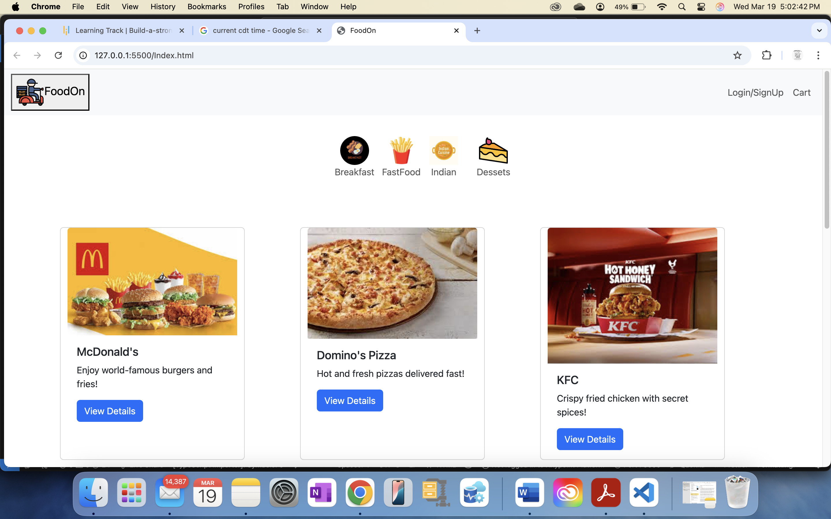



Users can browse the restaurants and food options without having to sign up or log in. However, they cannot add items to their cart. Clicking the “Add to Cart” button will add the food items to their cart.

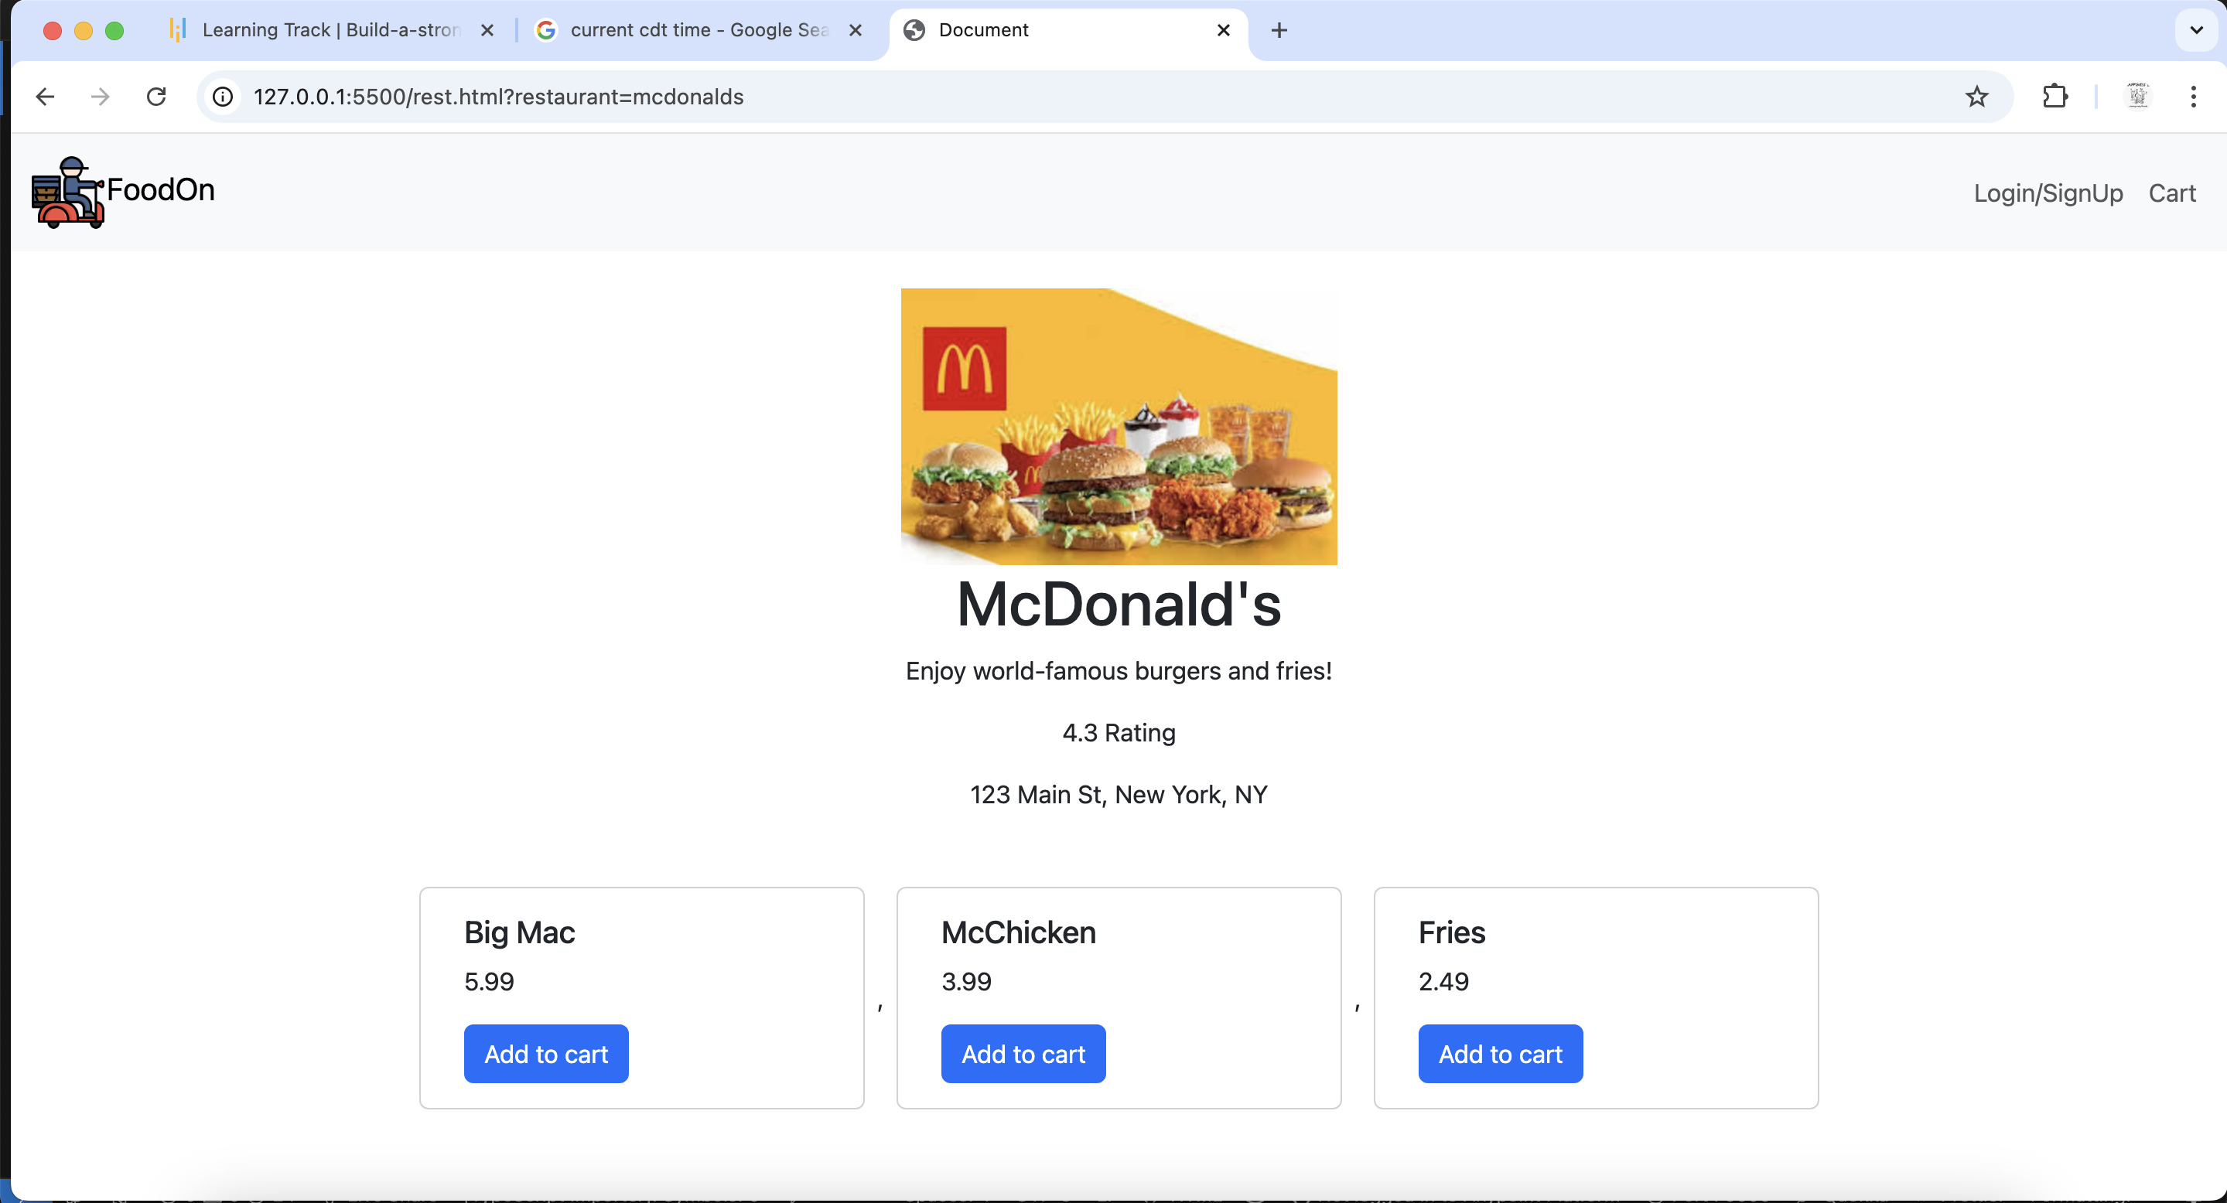

**Without User Authentication**

Users can explore the restaurants and food options without having to sign up or log in. However, they cannot add items to their cart.

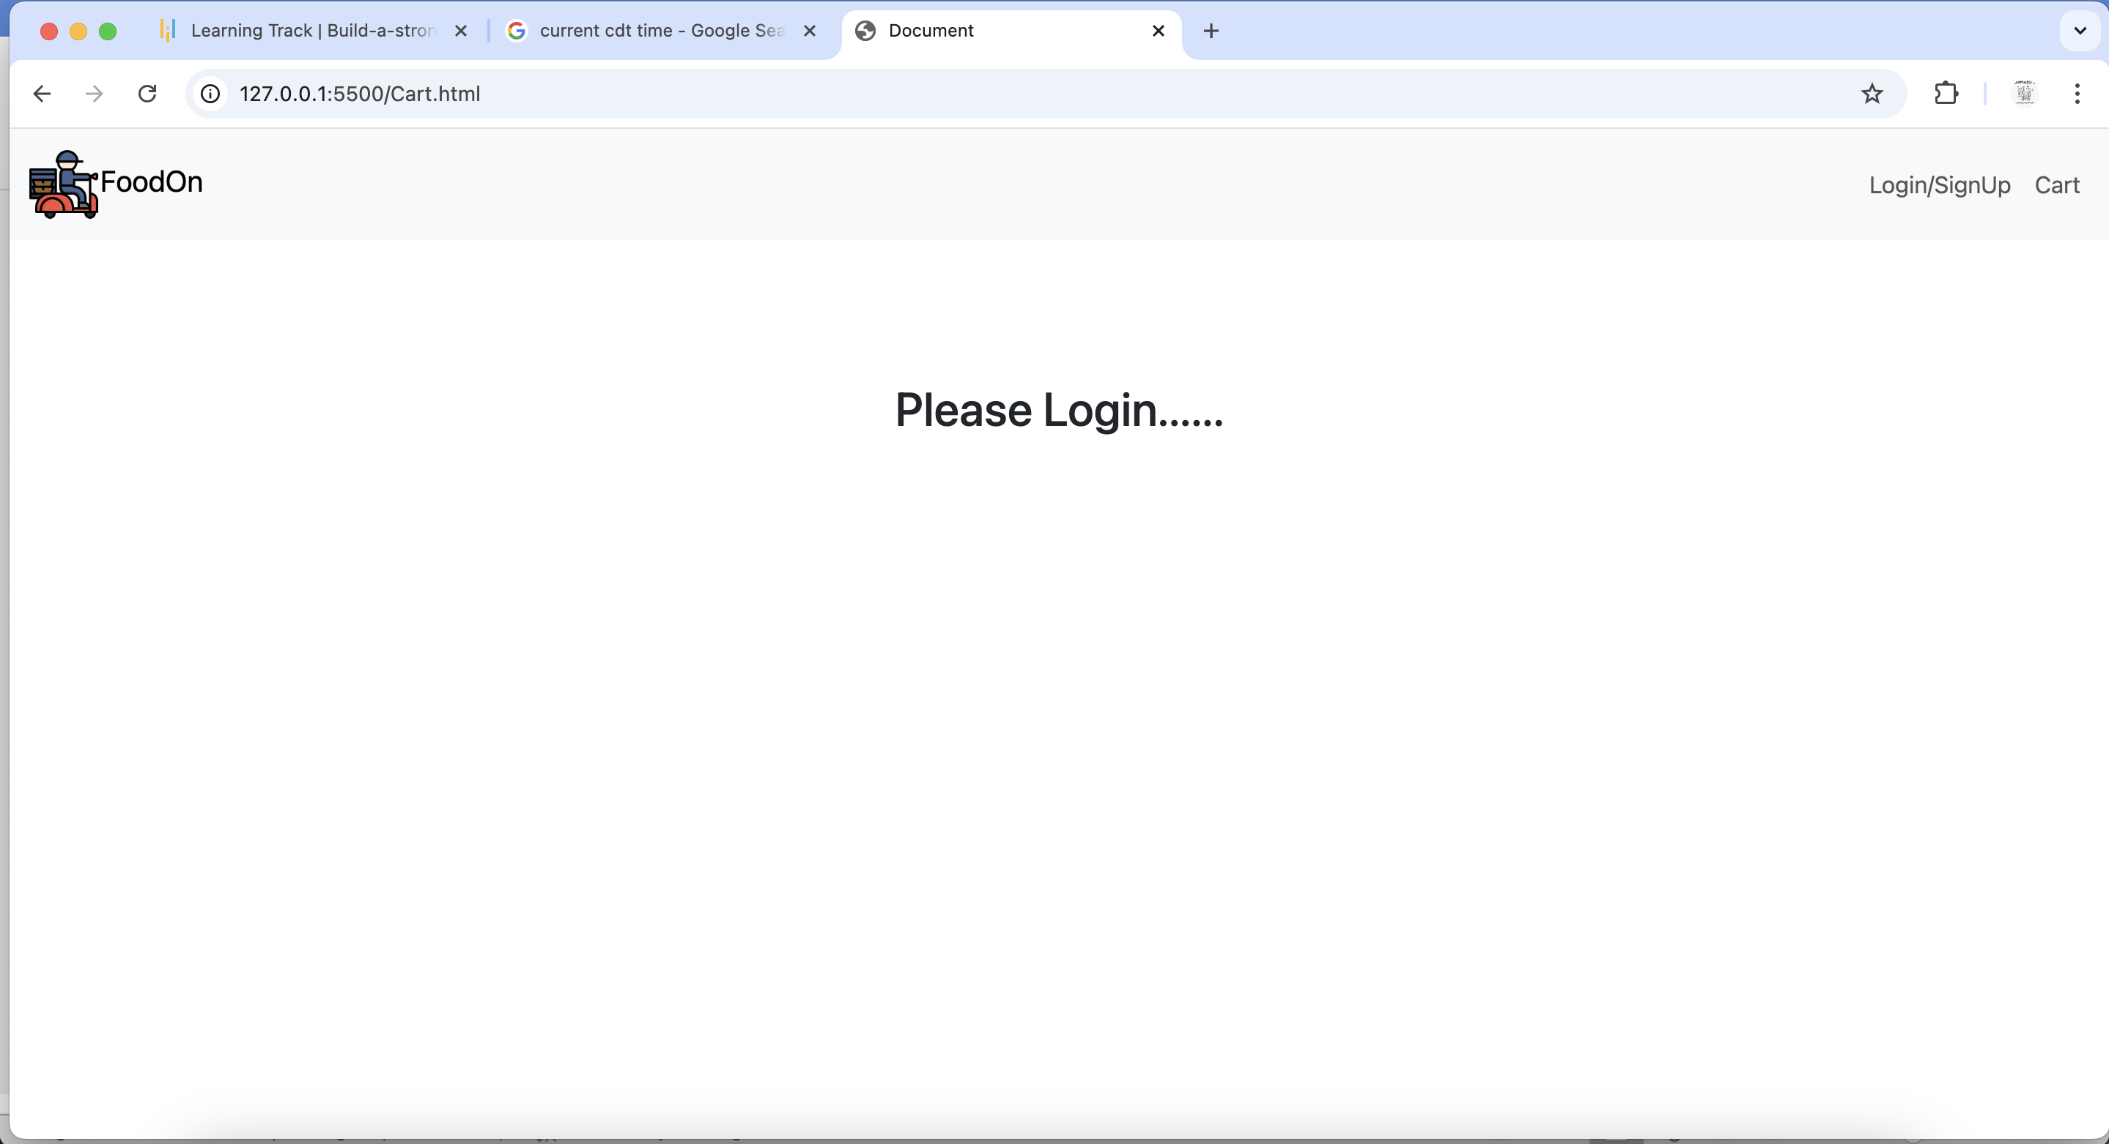

**User Authentication**

**Login/sigup**

Users can either log in or sign up, depending on whether they are new or not.

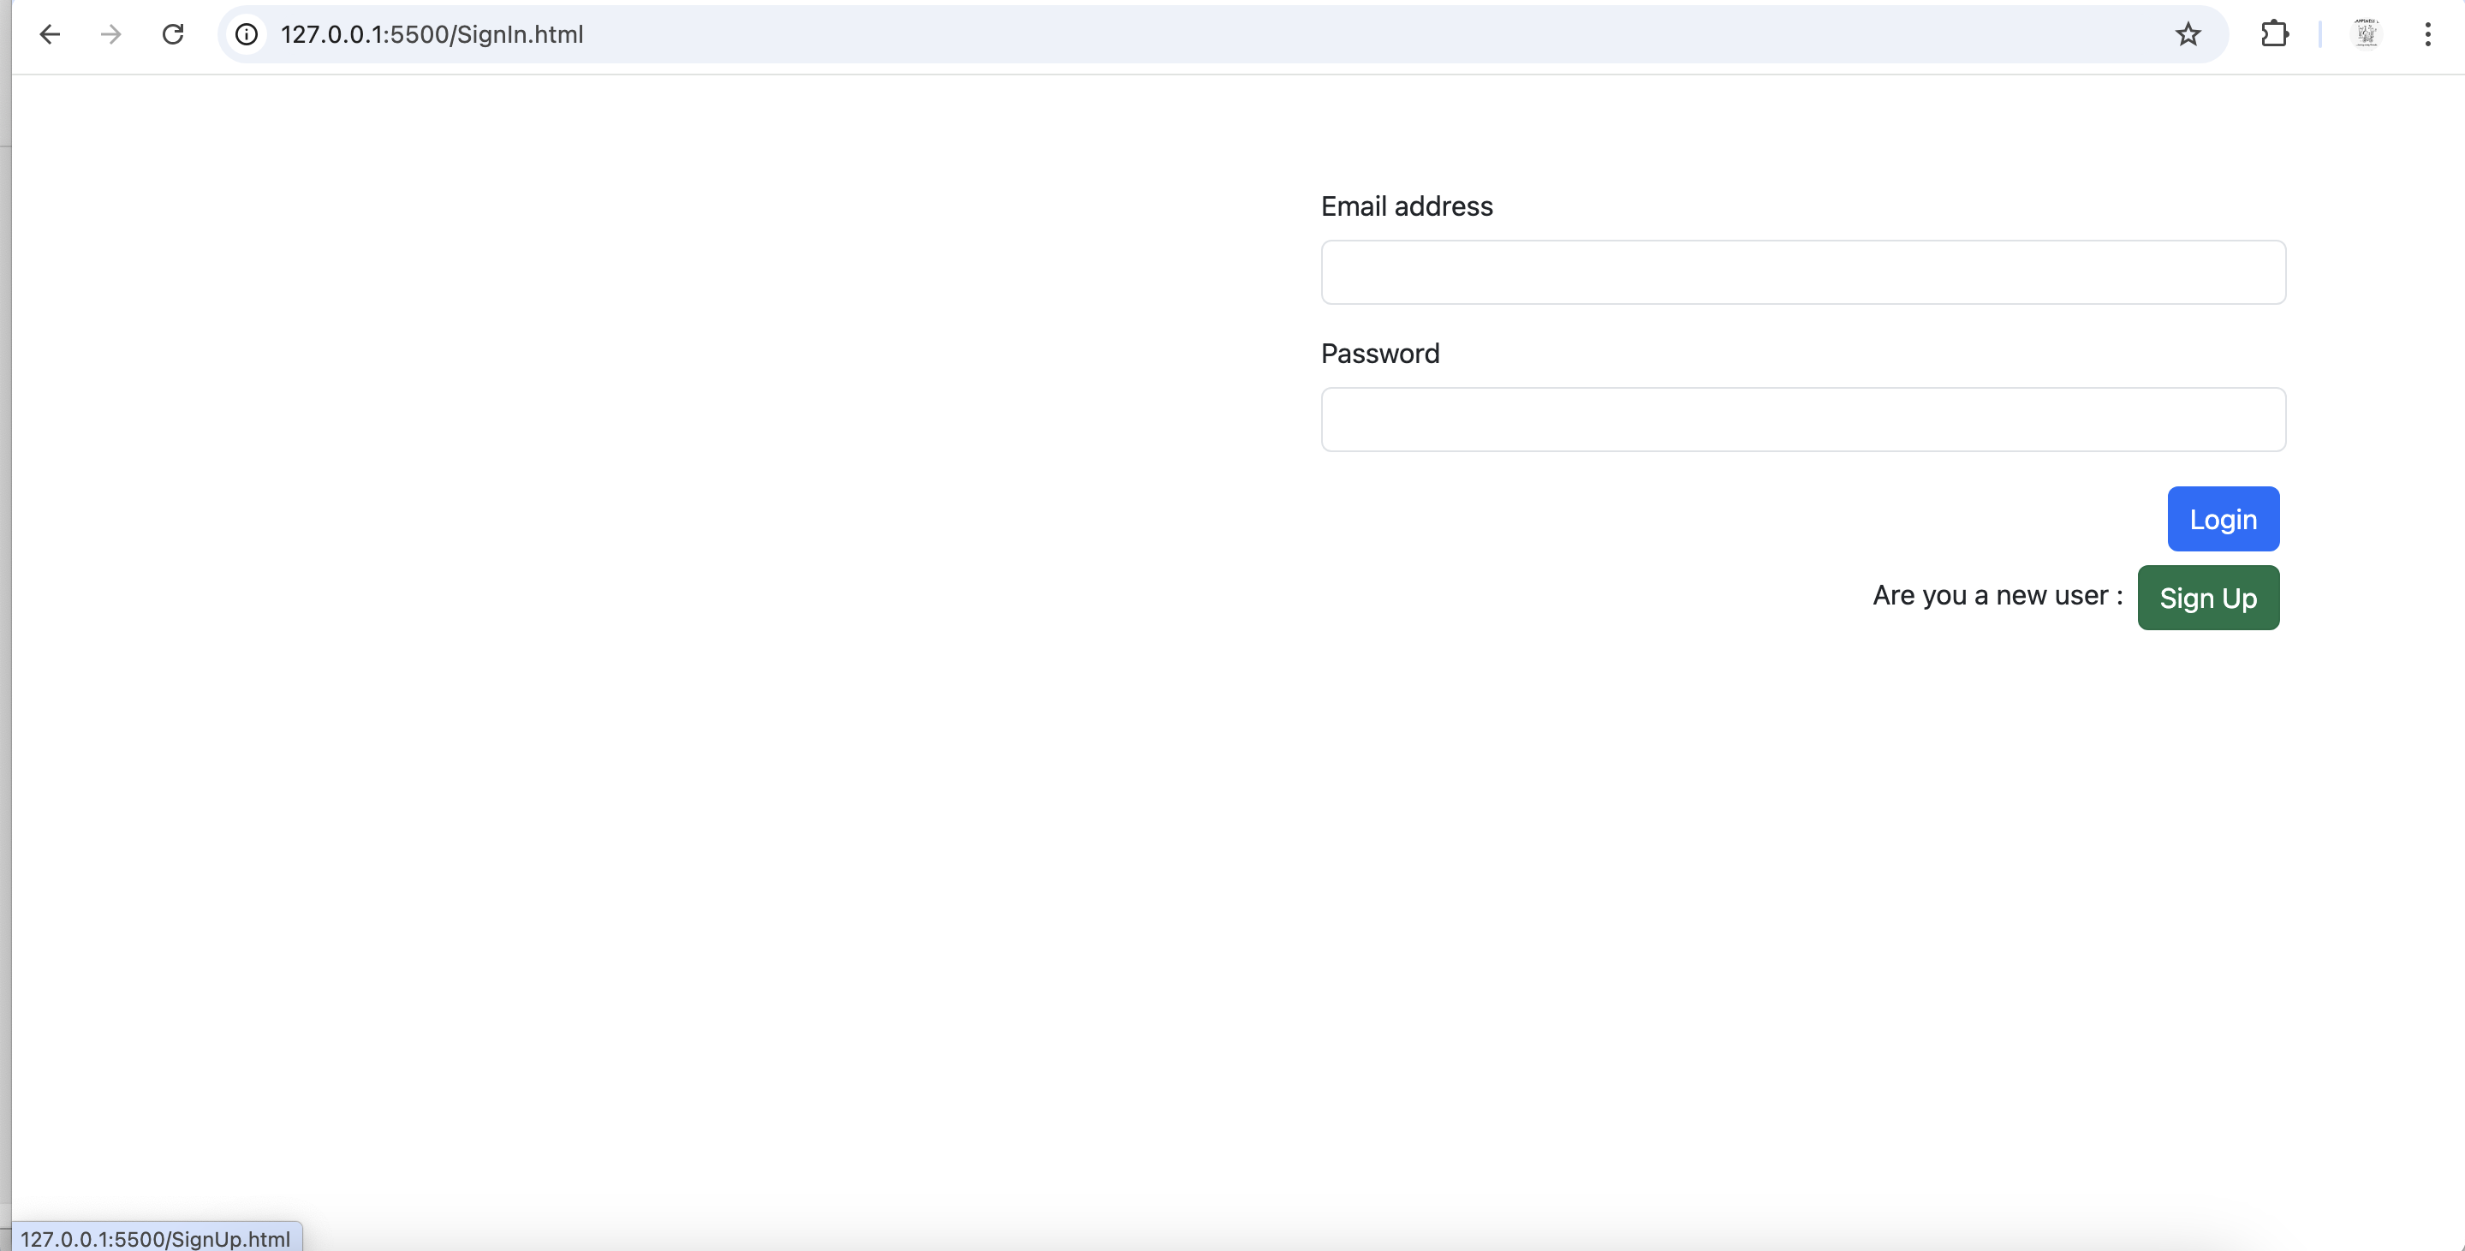

**SignUp**

User need to provide the required fields

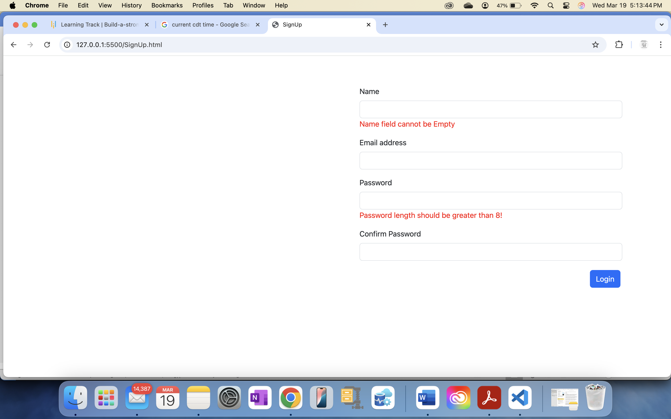

Once user gives the information click Login

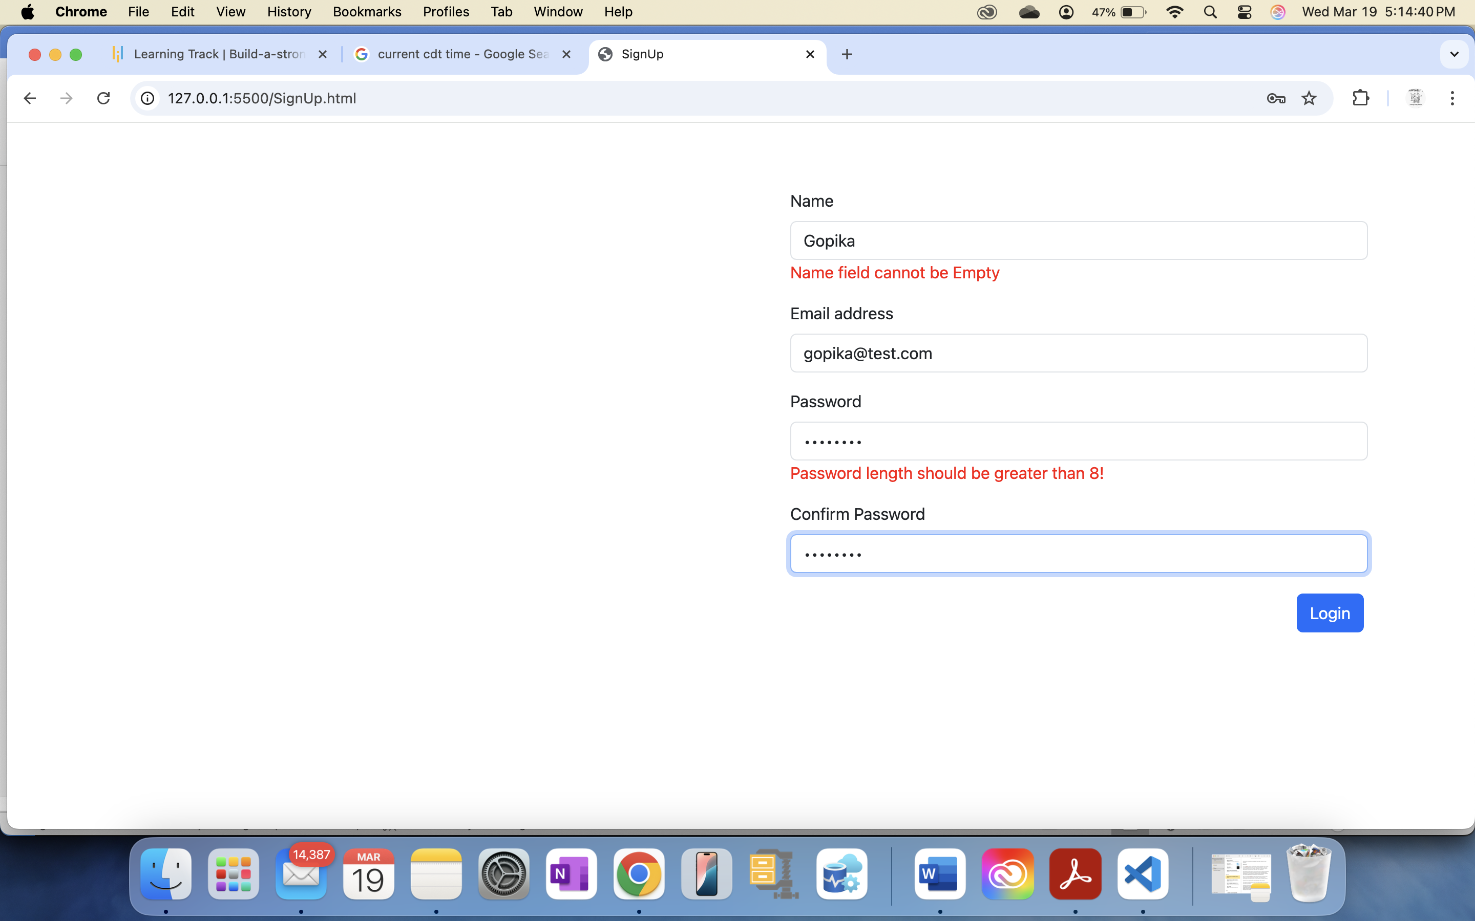

Once the user logs in, the page will be directed to the Home page, and the user will need to log in again to access the application.

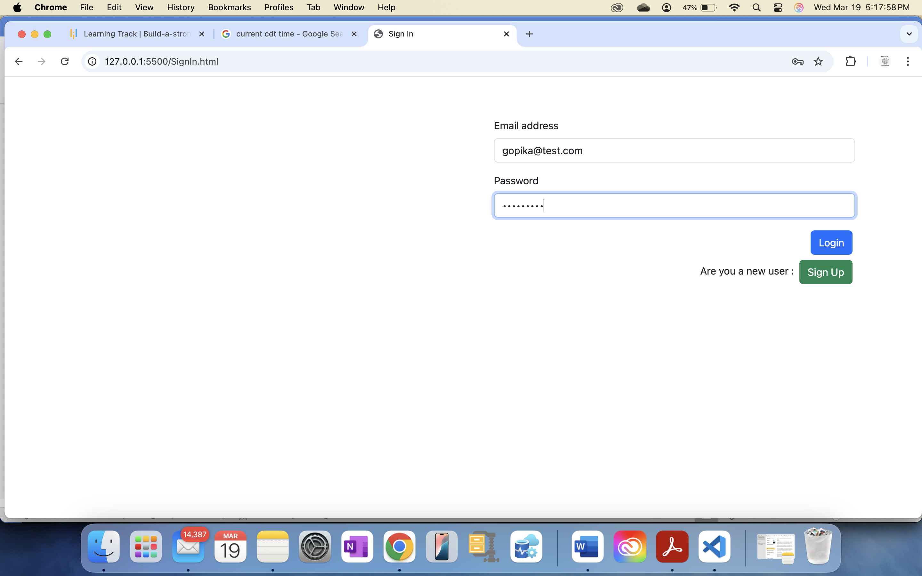

Now, the user can add items from the restaurant by clicking the “Add to Cart” button. These items will then be available in the cart.

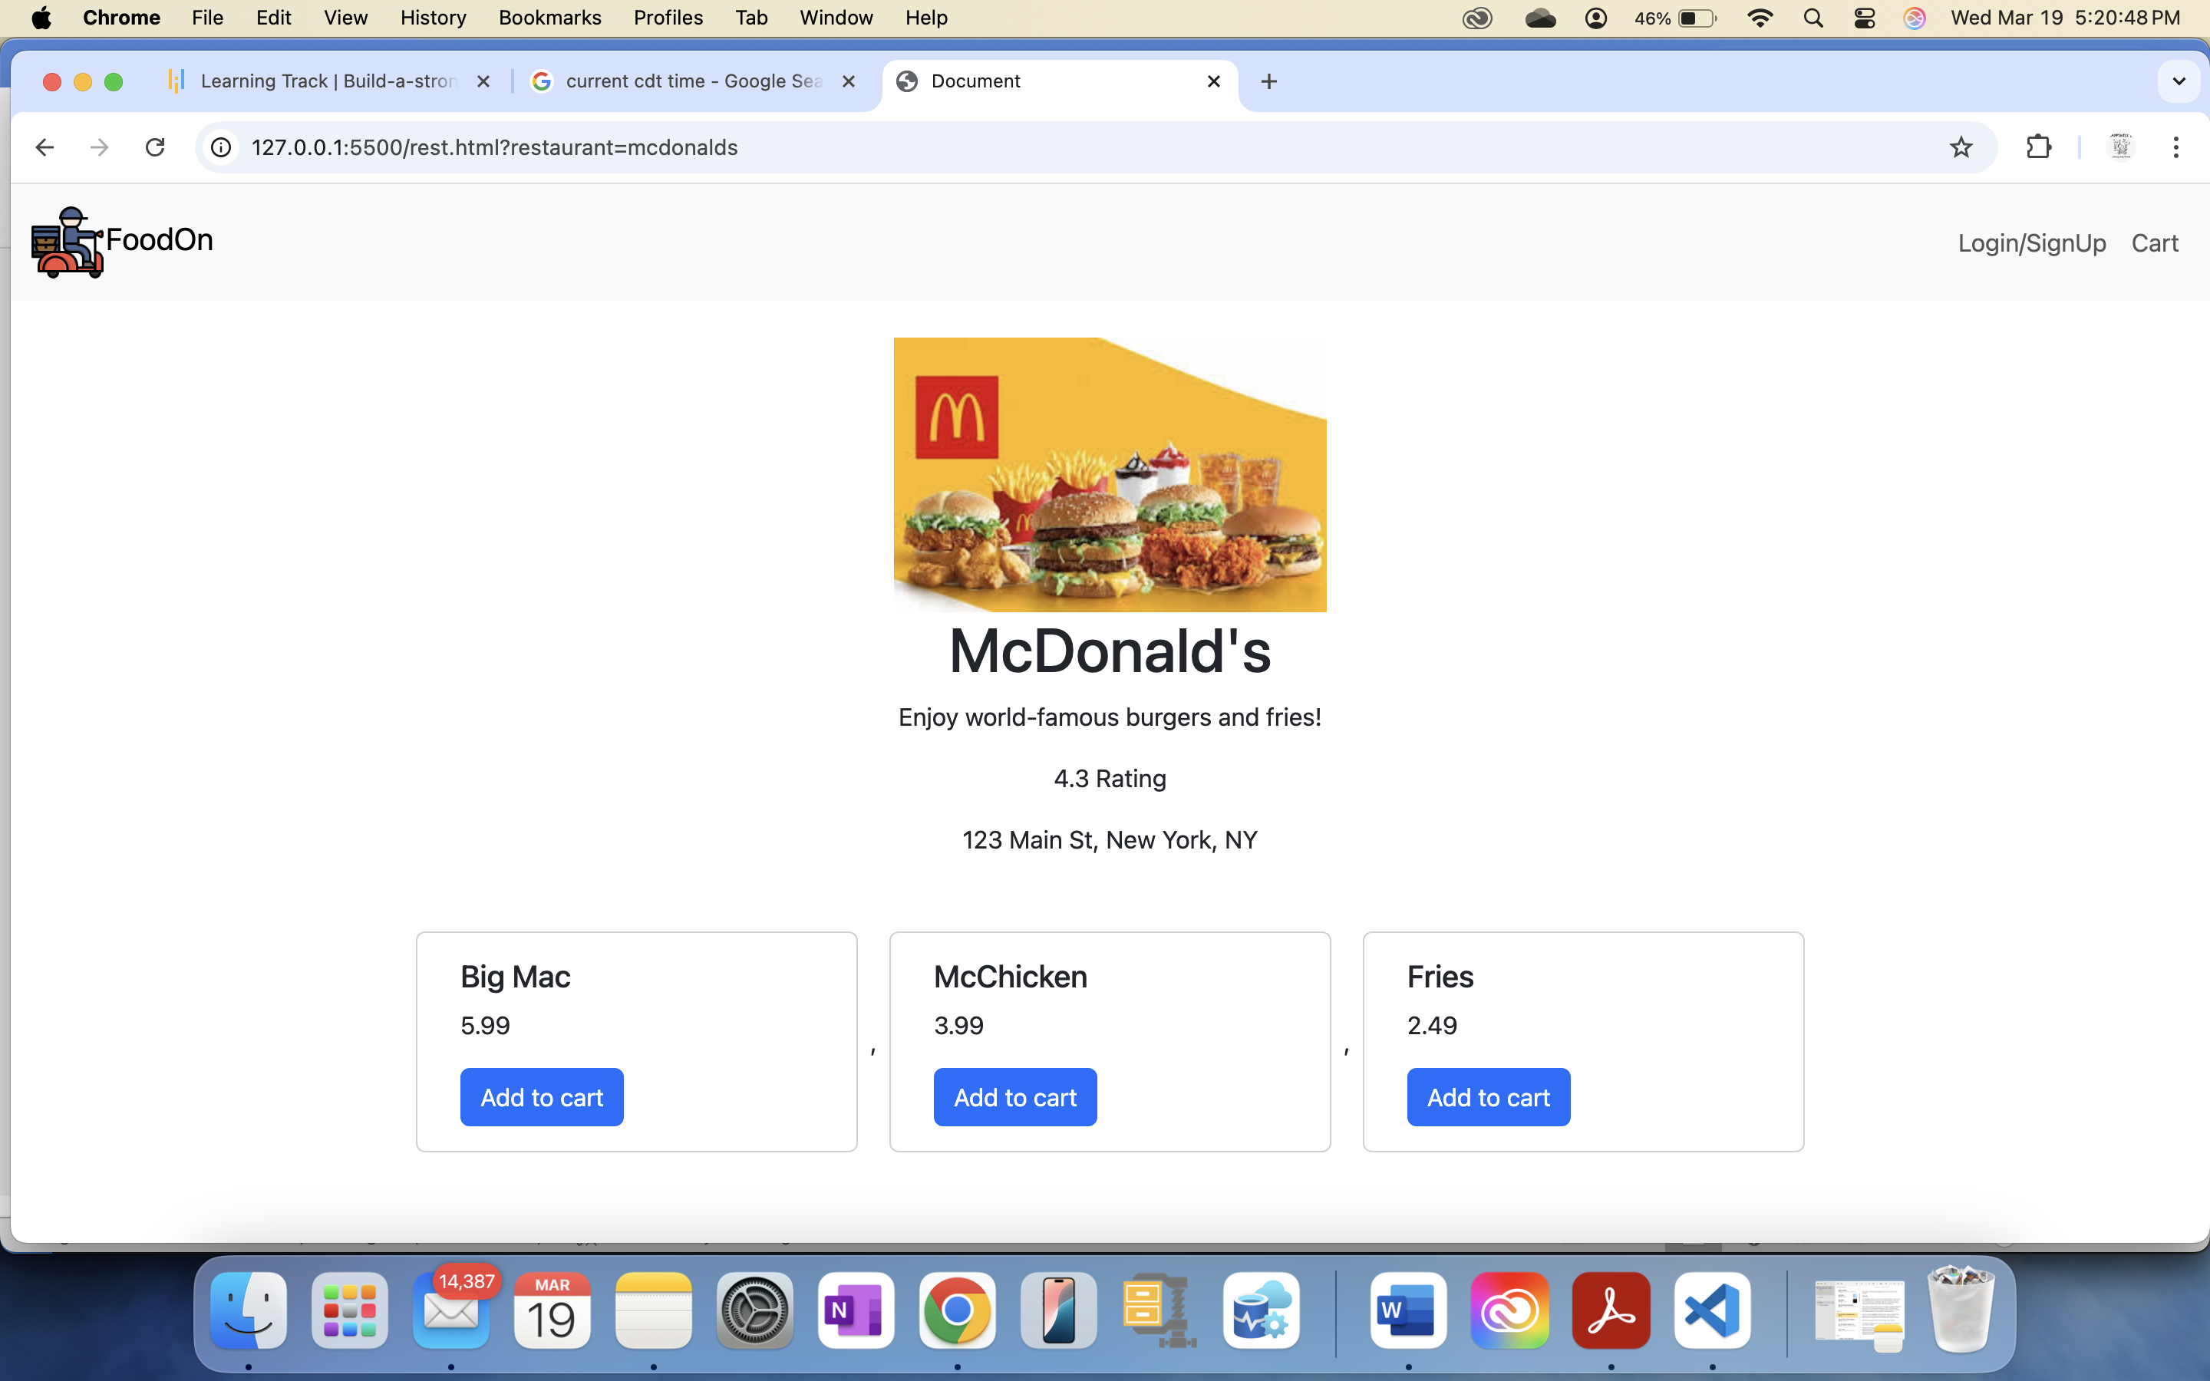

Users can increase or decrease the quantity of each item in their cart. The total price will be displayed on the page. By clicking the Pay button, users will be redirected to the payment page.

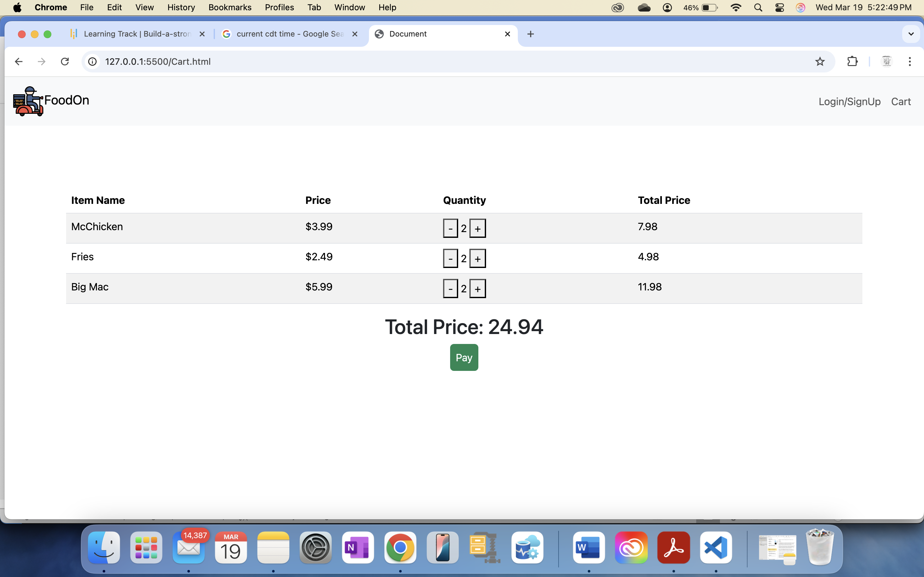

Payment page



Payment page have the below validations

